**Te Hoe Rorohiko**

**Department of Business and Digital Technologies**

Student Name ………James Callaghan………………………………………… Student ID ……99222398………………………….

**New Zealand Diploma in Information Technology Technical Support (Level 5)**

**New Zealand Diploma in Web Development and Design (Level 5)**

**Database Design DTEC502**

**Practical Assessment – SQL Test**

**Semester 1 2021**

**Date: Friday, 11th June 2021**

**Time: 8.00am – 10.00am**

**Time Allowed: 2 hours 00** **minutes**

Students are encouraged to read through the exam in the first ten (10) minutes and ask any questions.

**Instructions:**

Answer **ALL** questions.

This is an **OPEN** resources test.

Students are allowed to use their **OWN** resources.

All required files located on the DTEC502 Moodle site under the “FINAL SQL Practical Tests” tab.

**TOTAL MARKS:** 50

*Ara Institute of Canterbury and its division members reserve the right to use electronic means to detect and help prevent plagiarism.*

This test worth **25%** of the total marks for this course.

This assignment has eight (8) pages including the cover sheet. 

1. Open and execute the script file **ClientOrders.sql.**

# (Mark 1)

# 

|  |  |  |
| --- | --- | --- |
| 2. | List only those clients that live in Dunedin.  SELECT firstname, lastname, city  FROM client  WHERE city = 'Dunedin';  GO | **(Mark 1)** |
| 3. | List the clients whose last name begins with the letter J.  SELECT firstname, lastname  FROM client  WHERE lastname LIKE 'J%';  GO | **(Marks 1)** |
| 4. | Which clients have a balance between $50 and $150?  SELECT firstname, lastname, balance  FROM client  WHERE balance BETWEEN 50 AND 150;  GO | **(Marks 1)** |
| 5. | What city does our client Mary Nelson live in?  SELECT firstname, lastname, city  FROM client  WHERE firstname = 'Mary' AND lastname = 'Nelson';  GO | **(Marks 2)** |
| 6. | Which clients have a balance below $200 and live in Dunedin?  SELECT firstname, lastname, balance, city  FROM client  WHERE balance < 200 AND city = 'Dunedin';  GO |  |

# (Marks 2)

7. What is the difference between the clients limit and their current balance for each client? (Hint: calculate the limit field minus the balance field). Name the field you create NewBalance.

SELECT custref, creditlimit, balance, (creditlimit - balance) AS NewBalance

FROM client;

GO

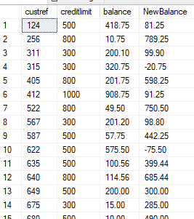

# (Marks 3)

1. What is the total price for each line of the order? (Hint: multiply the quantity by the quotedprice) Name the new field LineTotal.

SELECT orderref, partref, quantity, quotedPrice,(quantity * quotedPrice) AS LineTotal

FROM orderline;

GO

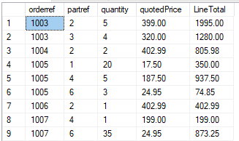

**(Marks 2)**

1. Which client orders (Custorder) were place after 1/6/99?

SELECT orderref, orderdate

FROM custorder

WHERE orderdate > '1999/06/01';

GO

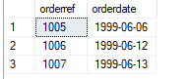

**(Marks 2)**

1. How many clients live in each city where the number of clients is more than 3?

SELECT COUNT(custref) AS NumClientsLivingInCity, city

FROM client

GROUP BY city

HAVING COUNT(custref) > 3;

GO

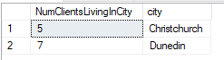

# (Marks 3)

|  |  |  |
| --- | --- | --- |
| 11. | What is the total balance for each sales rep?  SELECT rep.repref, SUM(client.balance) AS TotalBalance  FROM rep  INNER JOIN client ON client.repref = rep.repref  GROUP BY rep.repref;  GO | **(Marks 2)** |
| 12. | What is the maximum balance for each city?  SELECT city, MAX(balance) AS MaximumBalance  FROM client  GROUP BY city;  GO | **(Marks 2)** |

1. List all of our clients and their client representatives (repref). Display the client

name as one field, and the rep name as one field. **(Marks 3)**

SELECT firstname + ' ' + lastname AS ClientName, (rep.RepFirstname + ' ' + rep.RepLastName) AS RepName

FROM client

INNER JOIN rep ON rep.repref = client.repref;

GO

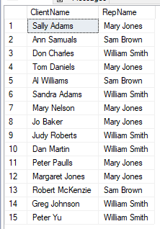

1. List the first and last name of the clients next to their customer order (custorder) and include the date of the customers order.

SELECT custorder.orderref, firstname, lastname, custorder.orderdate

FROM client

INNER JOIN custorder ON custorder.custref = client.custref;

GO

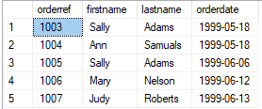

# (Marks 2)

15. What are the descriptions and amount on hand of the parts that appear on orderline 1007. Show only the records for 1007 in your answer?

SELECT orderref, part.description, part.onHand

FROM orderline

INNER JOIN part ON part.partref = orderline.partref

WHERE orderref = 1007;

GO



# (Marks 2)

DTEC02-2021-Practical Test.docx 2/06/2021 Page 2

1. List the description of the parts and their quoted price and quantity on each orderline. Sort by description.

**(Marks 3)**

SELECT orderline.orderref, description, orderline.quotedPrice, orderline.quantity

FROM part

INNER JOIN orderline ON orderline.partref = part.partref

ORDER BY description;

GO

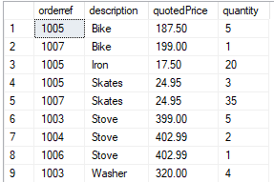

1. List the description of the parts and their quoted price and quantity on each orderline. Only display the records that have a quoted price over 200.

SELECT orderref, part.description, quotedPrice, quantity

FROM orderline

INNER JOIN part ON part.partref = orderline.partref

WHERE quotedPrice > 200;

GO

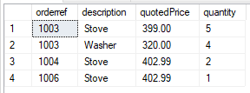

**(Marks 3)**

1. List all orders (order ref, order date), the client name for those orders, and all

part descriptions and unit prices. **(Marks 3)**

SELECT custorder.orderref, orderdate, client.firstname, client.lastname, part.description, part.unitPrice

FROM custorder

INNER JOIN client ON client.custref = custorder.custref

INNER JOIN orderline ON orderline.orderref = custorder.orderref

INNER JOIN part ON part.partref = orderline.partref;

GO

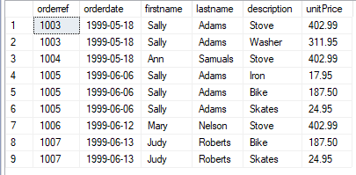

1. List all orders (order ref, order date), the client name for those orders, and all part descriptions and unit prices. Display only the records where the order

date is after 10/6/99. **(Marks 3)**

SELECT orderline.orderref, custorder.orderdate, client.firstname, client.lastname, part.description, part.unitPrice

FROM orderline

INNER JOIN custorder ON custorder.orderref = orderline.orderref

INNER JOIN client ON client.custref = custorder.custref

INNER JOIN part ON part.partref = orderline.partref

WHERE custorder.orderdate > '1999/06/10';

GO

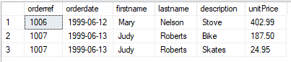

1. List all orders (order ref, order date), the client name for those orders, the rep’s name, and all part descriptions. **(Marks 3)**

SELECT custorder.orderref, orderdate, client.firstname, client.lastname, rep.RepFirstname, rep.RepLastName, part.description

FROM custorder

INNER JOIN client ON client.custref = custorder.custref

INNER JOIN rep ON rep.repref = client.repref

INNER JOIN orderline ON orderline.orderref = custorder.orderref

INNER JOIN part ON part.partref = orderline.partref;

GO

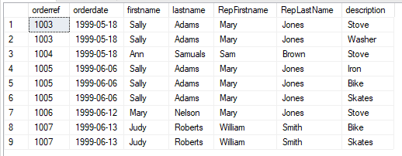

1. What is the total balance for each sales rep. Display the rep name as one

field. **(Marks 3)**

SELECT RepFirstname + ' ' + RepLastName AS RepName, SUM(client.balance) AS TotalBalance

FROM rep

INNER JOIN client ON client.repref = rep.repref

GROUP BY RepFirstname + ' ' + RepLastName;

GO

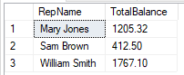

1. Using the answer from Question 8, now display the total linetotal (sum of

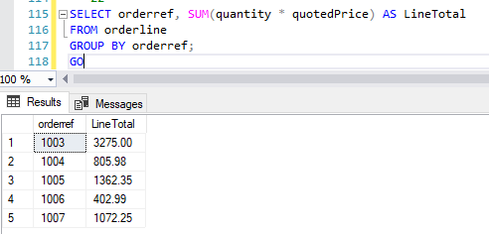

linetotal) for each Order (orderref). **(Marks 3)**

2/06/2021

**Required Outputs:**

**Q2.**

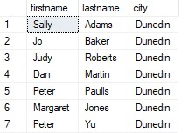

**Q3.**

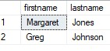

**Q4.**

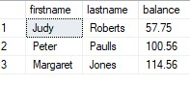

**Q5.**



**Q6.**

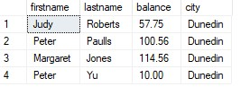

2/06/2021 Page 4

**Q7.**

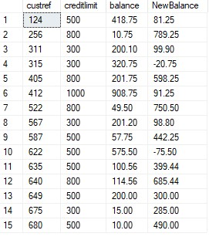

**Q8.**

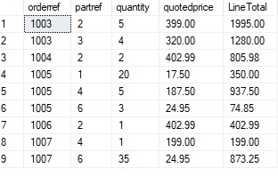

**Q9.**

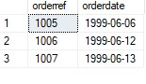

**Q10.**

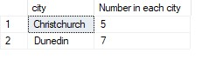

**Q11.**

2/06/2021 Page 5

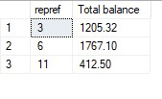

**Q12.**

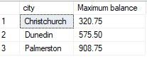

**Q13.**

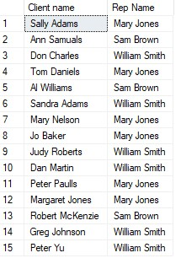

**Q14.**

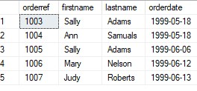

**Q15.**

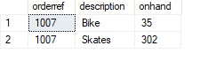

2/06/2021 Page 6

**Q16.**

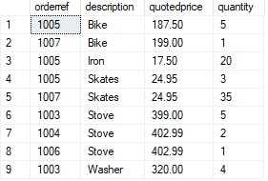

**Q17.**

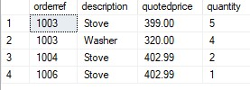

**Q18.**

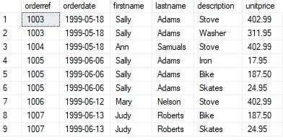

**Q19.**

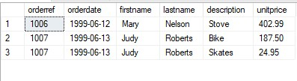

2/06/2021 Page 7

**Q20.**

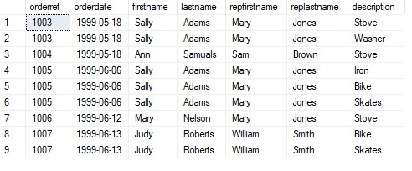

**Q21.**

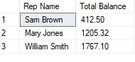

**Q22.**

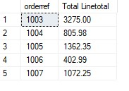

2/06/2021 Page 8